[[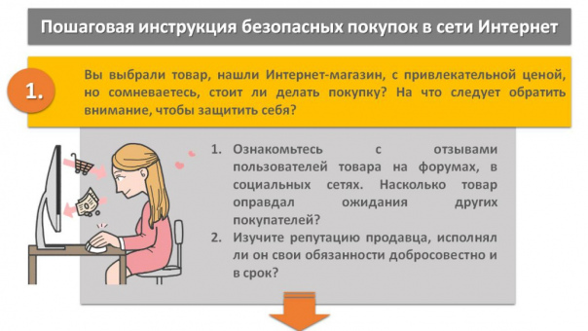](https://vk.com/doc741863691_670902736?hash=qIYyOxGebeAtC1f6KqdOir8V6Yg2jrZO264GXB4u9u4&dl=Oyb2vvOB9im070B9fTKTLZUot9Zzg4xfTgxeg61NUZw)](https://vk.com/doc741863691_670902736?hash=qIYyOxGebeAtC1f6KqdOir8V6Yg2jrZO264GXB4u9u4&dl=Oyb2vvOB9im070B9fTKTLZUot9Zzg4xfTgxeg61NUZw" \t "_blank)

[[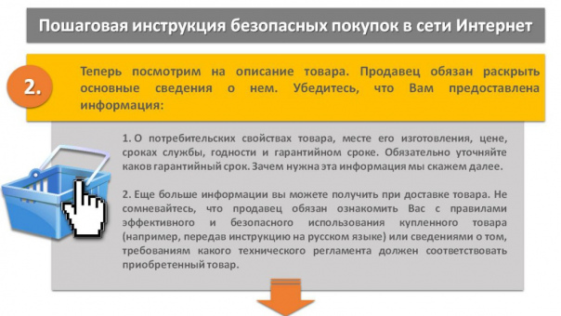](https://vk.com/doc741863691_670902737?hash=4lxzx0Y1bD3seyUQ4DvVlo4t6cHM9UPcTPRDQnERc7H&dl=fPdiXB5dgkX7LoKR4hxwJjSQkPZfjw7V1zuXLOrUagP)](https://vk.com/doc741863691_670902737?hash=4lxzx0Y1bD3seyUQ4DvVlo4t6cHM9UPcTPRDQnERc7H&dl=fPdiXB5dgkX7LoKR4hxwJjSQkPZfjw7V1zuXLOrUagP" \t "_blank)

[[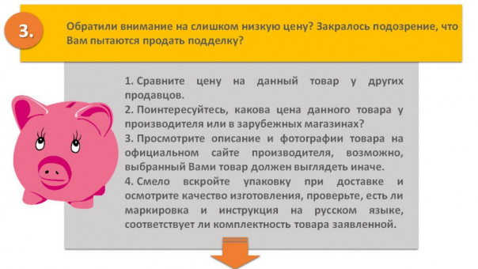](https://vk.com/doc741863691_670902738?hash=RFwDGr8S0KBNRtkQhMb3NkIJZJIp1CcOVizIEzklZT0&dl=iYcJh0XzVL9ljiPgwCZrMhAZmNHi1sJnSpMzQPz7Azs)](https://vk.com/doc741863691_670902738?hash=RFwDGr8S0KBNRtkQhMb3NkIJZJIp1CcOVizIEzklZT0&dl=iYcJh0XzVL9ljiPgwCZrMhAZmNHi1sJnSpMzQPz7Azs" \t "_blank)

[[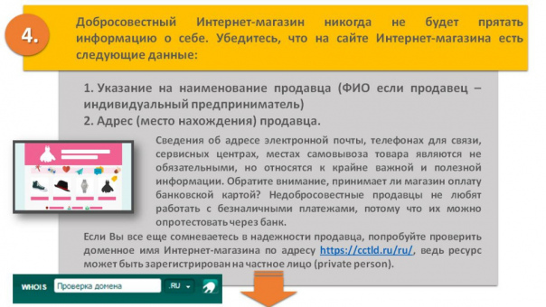](https://vk.com/doc741863691_670902739?hash=7ZabDfWdZvBqwa1pqg3GDsrp7vZPPCK9iy2LzPY4dlo&dl=IWYr1cxTp4SJ1t5GwFDQzIiZn33mfUz7pfuMgz8zEbs)](https://vk.com/doc741863691_670902739?hash=7ZabDfWdZvBqwa1pqg3GDsrp7vZPPCK9iy2LzPY4dlo&dl=IWYr1cxTp4SJ1t5GwFDQzIiZn33mfUz7pfuMgz8zEbs" \t "_blank)

[[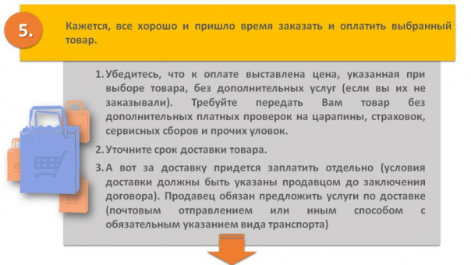](https://vk.com/doc741863691_670902740?hash=TSO4YyEbMkw8eDANkCgff7oKyitrTySaw1QO9TN62Dk&dl=aHzkSKQyqmDthLpSbZtTsaxhFuyCdXTMjQ7LWG9MZ08)](https://vk.com/doc741863691_670902740?hash=TSO4YyEbMkw8eDANkCgff7oKyitrTySaw1QO9TN62Dk&dl=aHzkSKQyqmDthLpSbZtTsaxhFuyCdXTMjQ7LWG9MZ08" \t "_blank)

[[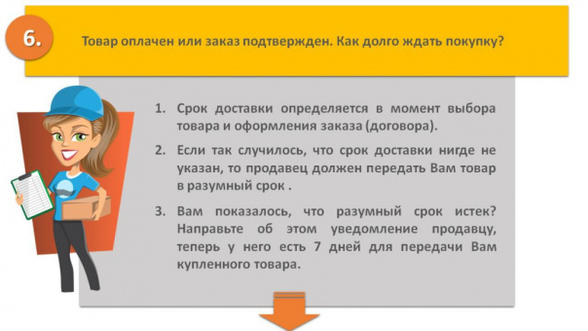](https://vk.com/doc741863691_670902741?hash=KnH8uc9oJruS9X3wBmIvzEi8eKxMxrTuU8X1zWWSZuH&dl=EDvZktZzlksFu8u5kLZDae3csSMMGPUJbbmZEo1oCyT)](https://vk.com/doc741863691_670902741?hash=KnH8uc9oJruS9X3wBmIvzEi8eKxMxrTuU8X1zWWSZuH&dl=EDvZktZzlksFu8u5kLZDae3csSMMGPUJbbmZEo1oCyT" \t "_blank)

[[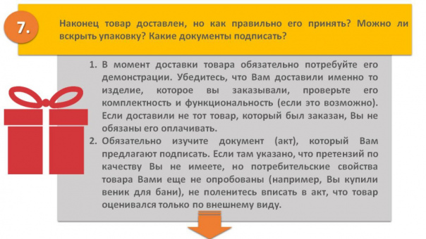](https://vk.com/doc741863691_670902742?hash=PvboXtTXm8hTlHcLBLSlEjTR3ti9iLxtjTtI0fcBnpT&dl=tvIK4vAeTEJPSnshOfDxxy7kaW6QlaiBEoSZ0pDX5uc)](https://vk.com/doc741863691_670902742?hash=PvboXtTXm8hTlHcLBLSlEjTR3ti9iLxtjTtI0fcBnpT&dl=tvIK4vAeTEJPSnshOfDxxy7kaW6QlaiBEoSZ0pDX5uc" \t "_blank)

[[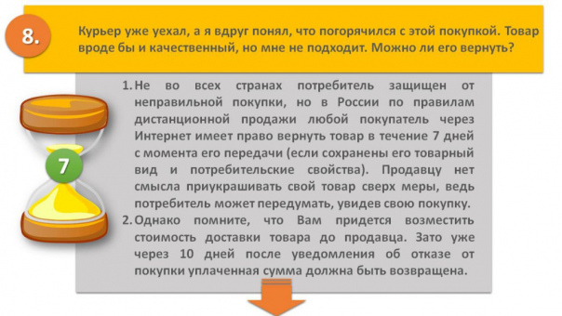](https://vk.com/doc741863691_670902744?hash=7MKTJuOiOEexHehlaU3NOTV2pypThe1scLV756A0lNc&dl=jDPbU1rwgR4m1LVN30ef2yXbiLwikG1mMyytD8hgme8)](https://vk.com/doc741863691_670902744?hash=7MKTJuOiOEexHehlaU3NOTV2pypThe1scLV756A0lNc&dl=jDPbU1rwgR4m1LVN30ef2yXbiLwikG1mMyytD8hgme8" \t "_blank)

[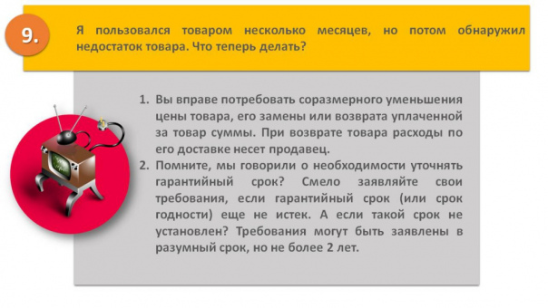](https://vk.com/doc741863691_670902745?hash=sHNKi6I2KRmmZRfFwQA1iMzw28hWzPwVgCUC65sC1Kz&dl=VY2c6iepxHvuBaalruNMfNokkYR3tgG91BiT2ILrOOo)